**Assignment no 2**

1)

#include<iostream>

using namespace std;

class student

{

int rollno,marks;

char Name[25];

public:

void GetData();

void PutData();

};

void student :: GetData()

{

cout<<"\n\tEnter student rollno : ";

cin>>rollno;

cout<<"\n\tEnter student Name : ";

cin>>Name;

cout<<"\n\tEnter student marks : ";

cin>>marks;

}

void student :: PutData()

{

cout<<"\n student rollno : "<<rollno;

cout<<"\n student Name : "<<Name;

cout<<"\n student marks : "<<marks;

}

int main()

{

student E;

E.GetData();

E.PutData();

}

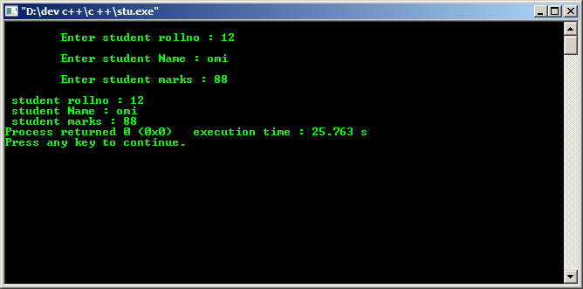

2)

#include <iostream>

using namespace std;

int main()

{

int rad1,hgt;

float volcy;

cout << "\n\n Calculate the volume of a cylinder :\n";

cout << "-----------------------------------------\n";

cout<<" Input the radius of the cylinder : ";

cin>>rad1;

cout<<" Input the height of the cylinder : ";

cin>>hgt;

volcy=(3.14*rad1*rad1*hgt);

cout<<" The volume of a cylinder is : "<< volcy << endl;

cout << endl;

return 0;

}

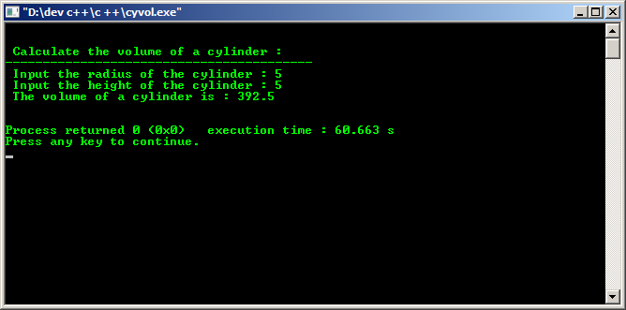

3)

#include<iostream>

using namespace std;

class Employee

{

int Id;

char Name[25];

long Salary;

public:

void GetData();

void PutData();

};

void Employee :: GetData()

{

cout<<"\n\tEnter Employee Id : ";

cin>>Id;

cout<<"\n\tEnter Employee Name : ";

cin>>Name;

cout<<"\n\tEnter Employee Salary : ";

cin>>Salary;

}

void Employee :: PutData()

{

cout<<"\n\nEmployee Id : "<<Id;

cout<<"\nEmployee Name : "<<Name;

cout<<"\nEmployee Salary : "<<Salary;

}

int main()

{

Employee E;

E.GetData();

E.PutData();

}

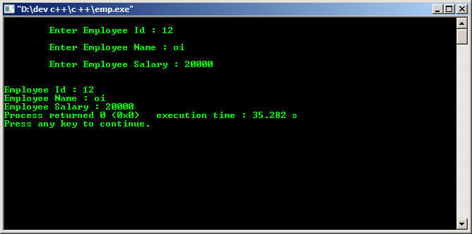

4)

#include <iostream>

using namespace std;

int main()

{

int n, t1 = 0, t2 = 1, nextTerm = 0;

cout << "Enter the number of terms: ";

cin >> n;

cout << "Fibonacci Series: ";

for (int i = 1; i <= n; ++i)

{

if(i == 1)

{

cout << " " << t1;

continue;

}

if(i == 2)

{

cout << t2 << " ";

continue;

}

nextTerm = t1 + t2;

t1 = t2;

t2 = nextTerm;

cout << nextTerm << " ";

}

return 0;

}

